 | 12.3.2 Editors - Geometry Nodes Editor - Sidebar - Node Tab
Table of content
Node Tab - Node Panel 1
Name 1
Label 1
Color sub menu 1
Color checkbox 1
Presets 1
Color 1
Node color specials 2
Copy Color 2
Node Tab - Properties Panel 2

Node Tab - Node Panel

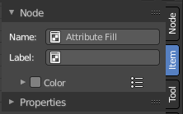
In this panel you can give nodes and node groups a name and a label, and change its color.

Name
The type of the node.

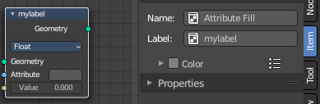
Label
The label name of the node.

Color sub menu

Color checkbox
The Color checkbox turns custom color on or off.

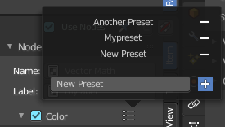
Presets
Store some color presets and reuse them. They are stored globally, and transfers to other blend files.

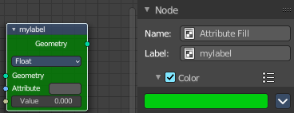
Color
Choose a custom color. A click at the color field will open a color picker.

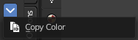
Node color specials

Copy Color
Allows you to copy the color.

Node Tab - Properties Panel
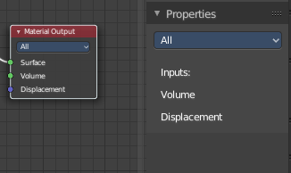
This panel shows usually the same properties than the properties at the node. These properties are already explained in the Add menu chapters. So we won't repeat them here.

